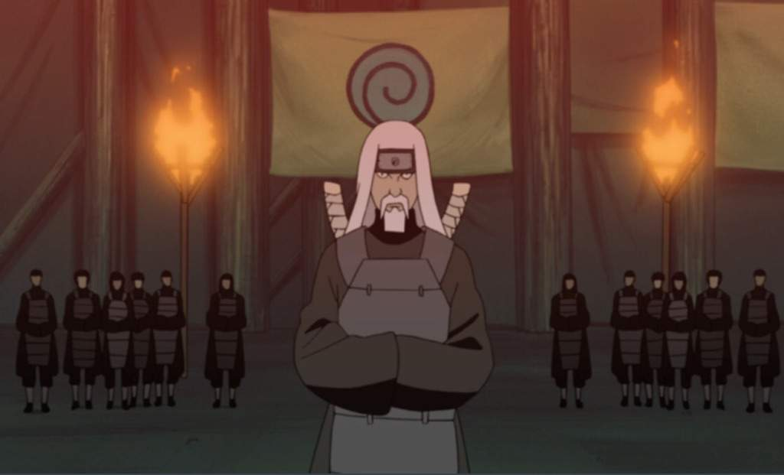

**Uzumaki Clan**

The Uzumaki (*うずまき一族, Uzumaki Ichizoku*) is one of the three nobles of Watashitachi wa, Kizoku. They are renown for their extreme vitality along with prowess and aptitude for Fuinjutsu. They are often regarded as genius’s in the subject so much that it was speculated many would come to Kizoku to learn from them once the Don’Yoku passed the Vassal Law.

History

**Preface**

The Uzumaki clan was one of the many clans Asahi of the First Flame is directly responsible for the creation of. Gifting them the method to seal Tailed Beast to handle and keep the chakra of the All-Beast split properly away from becoming whole again. The Uzumaki clan was firstly a group a scholar who studied heavily in the arts of Fuinjutsu, being one oldest established clan in the world. They would be designated the keepers of the All-Beasts nine fragments of chakra and looked over the vessels. Though due to their lack of combat skills they could not rightly defend the vessels from being stolen by outside sources once Asahi had passed and outside sources looked to use their power for their own bidding. After time passed, they had lost all of the vessels, but it was soon realized no other clan had the level of Fuinjutsu needed to control them, and many had their factions destroyed by the rampaging beasts. Due to their prowess in dealing with the Tailed Beast the Uzumaki were inducted as nobles, granted housing with the Senju Clan so they could study and progress in their art of Fuinjutsu without worrying about combat. Though once the Senju fell from power, they were called to arms and had to take up the life of a Shinobi in the great plan to restore themselves back to noble status.

One Uzumaki who stood out was Shisae, the first Uzumaki to master the Adamantine Chain technique and being noted as “Shisae of the Tailed Beast” for playing a large part in the capture and sealing of several of the Tailed Beast. It was said she lived to be 120 before dying of natural causes, still looking to be in her mid-50’s, her hair recently beginning to lose color.

**Current**

The Uzumaki now work with the Senju and Hyuuga to restore Kizoku to its former glory, although much like other residents of Kizoku they are not used to the simpler life. Coming from fame and fortune they have very little aptitude for things such as yardwork and farming, often overthinking the subject at hand. They are stilled turned to in the subject matter of Tailed Beast, houses often setting aside their differences for this reasoning. However, Uzumaki often request a large sum of currency when dealing with Tailed Beast matters, making them one of the highest paid clans through The Isle.

Description

The Uzumaki are known for their crimson hair and abundance of vitality and energy. They are known to look strikingly young even when aged. They are known to wear vibrate colors and have a very unique and high fashion sense.

The Uzumaki are often very energetic people. A mixture of a extremely advanced vocabulary and energetic speech pattern make their clan known for their talkative nature. They take great pride in their intellect, enough so that they become upset when they feel their intellect is being disrespected. Due to high payment to their clan some members can be increasingly greedy and materialistic as well.

Player Guide

*Uzumaki’s number 1 rule is that their services are not free, and they will often request payment for the simplest things such as their “time”. Uzumaki are extremely intelligent, and any Uzumaki that does not seem to speak with advanced vocabulary and terms is thought it be “Acting” or suppressing it. Uzumaki have their own written language used through Uzumaki Kanji, advanced enough to where they can communicate full messages through it with those untrained being none the wiser, even masters of Fuinjutsu cannot understand it. Uzumaki are not use to manual labor, farming, or repairing things on their own as they are the most pampered of the 3 noble clans.*

-Uzumaki have red-hair unless they are mixed with another clan. None are known to be currently.

-Uzumaki are known to be extremely energetic and eccentric.

-Uzumaki enjoy studying and researching things that interest them, making them experts on various matters.

-Uzumaki have the most advanced education known through The Isle. They have an understanding of all subjects to a degree that others cannot understand, and that rivals modern times.

-Uzumaki’s sense of fashion is flashy and they enjoy wearing bright colors, eccentric clothing, and unconventional accessories.

-Uzumaki have the most advanced vocabulary of any of the clans.

-The Uzumaki rarely show signs of aging pass a young adult, and it takes a while for them to look their age. Likely dying before the latter happens.

-The Uzumaki diet is a balanced, they incorporate many foods as well as foreign dishes others more than likely have never heard of. Some Uzumaki are known to have sweet tooths.

-Uzumaki can sometimes show traits of being greedy and material hungry, often basing their involvement around money alone.